- Preparation
To anchor a normal park with 18-22 play items, about 20 concrete blocks are needed,each with a weight of 450KG,into which metal rings must be inserted during productions. "sea Anchor Blocks"are available factory-madebut can also be constructed independently ,by joining lighter blocks,These blocks must be placed into the water near the installation site,then manoeuvred by divers using a hoisting buoy to the anchoring points of the park.For the use of hoisting buoys.a minimum water depth of 1.7 m is needed.

At the same time satisfy the three conditions can be used as fixed anchor point of the concrete blocks
1. the weight can be up to standard
2. the rope can be through the hole
3. for a long time in seawater is not broken
The following figure:
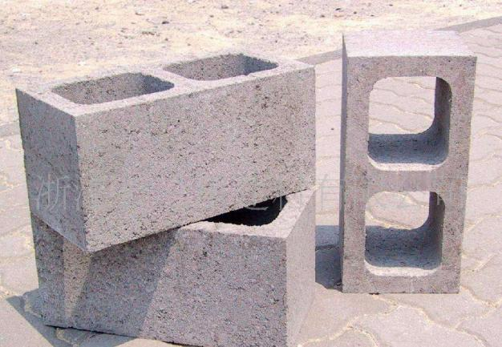

- Transport
Transport the elements to the sea 、 lakshore or pool. Each elements of the water park are heavy(e.g. 100-200KG,and could reach up to 700KG for an extreme size park);therefore use of smaller equipment,For example a forklift truck is advised for moving individual elements from the truck/warehouse to the shore

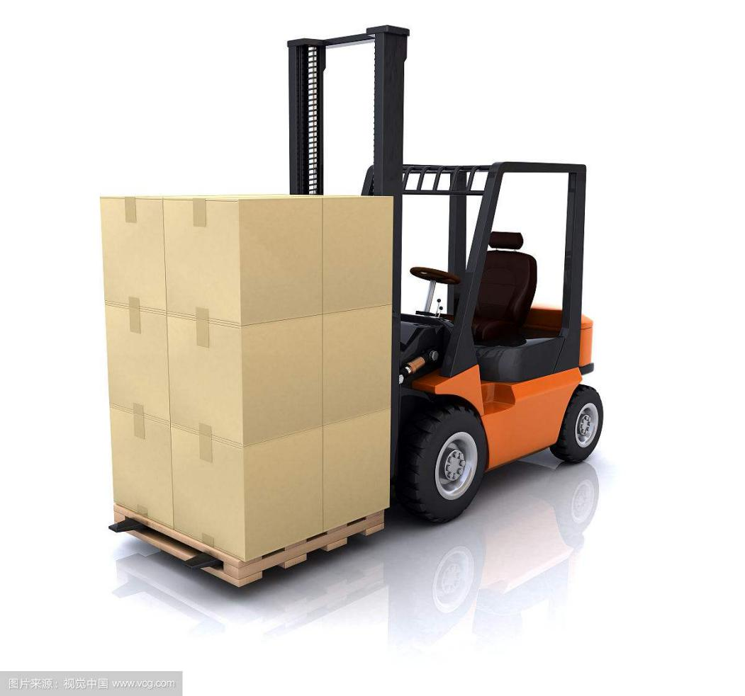
3.inflation
Note:Do not fully inflate inflatale elements(especiallly in the morning),as they will expand in the sun.90% of the units are equipped with a safety deflation valve.The ones not equipped with such valve should be inflated to pressure levels similar to other items(0.05-0.07 bar).
Unpack the park elements and open the valve cap
a.)Insert the nozzle of the pump into the valve,and lock it in place by twisting it clockwise,Start the pump to start inflating the element - you will need 230V power supply for this
b.)When you have inflated the product up to about 85% first shut off the pump,then disengage it by twisting it counterclockwise (check with a manometer that the pressure it 0.05-0.07 bar),and cover the valve
C.)For park elements with a "D" securing ring on their bottom,connect the flexible rope as shown in the image.Individual elements contain a different number of fixing points - if possible,connect a flexible rope to each of them.

Once you have inflated all elements,place them one by one on the water near the shore,and connect them according to the plans of the park.Use the D-rings located at the bottom of individual elements and the securing straps that join them for this.(see Figures 13-14-15-16).
Although certain elements of the water park are heavy,after inflating them they can be put to water manually (6-8 people).If you have purchased a large,extreme size water park,you will need a crane truck to lift the heavier elements onto the water surface.To facilitate lifting,we have fitted larger elements of the water park with D-rings.
Elements fitted with top eyelets should be joined using a securing rope threaded through the eyelets

Having connected the elements,cover their union with the Velcro flap

D-ring and belt buckle connecting two elements

4.Towing to the final location
After connecting the elements of the water park on the shore,very slowly tow them - with a jet ski,speedboat or boat -to their final location,using flexible ropes fitted into the bottom D-ring securing points of a larger element(e.g.Lifeguard Tower,Action Tower).Divers should arrange the concrete blocks manoeuvred there during preparations proportionallly underneath the park,and secure the park elements to the anchoring weights using flexible ropes(in deeper water extend the ropes).if you have also purchased individual park elements(e.g. Iceberg,Water Totter A-B-C,Saturn Rocker,Water Roller),place them in the area of the park,and secure those that require this.
the park will require no regular follow-up inflation,however,pressure checks need to be carried out several times a day.For this we supply a pressure gauge,an electric pump to replace the lost air,and a manual pump for smaller quantities of air replacement
5.safety zone
Cordon off the area of the water sports park with safety buoys
6.safety rules
Users of the water park must wear a safety vest.
The water depth should always conform to the minimum value for the given element! The minimum water depth can be calculated simply :height of the product + height of an average person (180CM),Diving the result by two.E.g.,the height of the Action Tower is 3M which gives 3m Plus1.8m divided by 2 equal 2.4 meter.
A steward must be present to ensure correct use of the park elements.
Users may not wear hair clips,watches,necklaces,bracelets,anklets,rings,or any other sharp object while playing in the park.People with heart conditions or high blood pressure may not use the park

